

Installing BizTalk Server 2009 on Windows Server 2008
Microsoft Corporation
Published: June 2009

Copyright
Information in this document, including URL and other Internet Web site references, is subject to change without notice. Unless otherwise noted, the companies, organizations, products, domain names, e-mail addresses, logos, people, places, and events depicted in examples herein are fictitious. No association with any real company, organization, product, domain name, e-mail address, logo, person, place, or event is intended or should be inferred. Complying with all applicable copyright laws is the responsibility of the user. Without limiting the rights under copyright, no part of this document may be reproduced, stored in or introduced into a retrieval system, or transmitted in any form or by any means (electronic, mechanical, photocopying, recording, or otherwise), or for any purpose, without the express written permission of Microsoft Corporation.
Microsoft may have patents, patent applications, trademarks, copyrights, or other intellectual property rights covering subject matter in this document. Except as expressly provided in any written license agreement from Microsoft, the furnishing of this document does not give you any license to these patents, trademarks, copyrights, or other intellectual property.
© 2009 Microsoft Corporation. All rights reserved.
Microsoft, Windows, Windows Server, Windows Vista, Active Directory, BizTalk, Excel, SharePoint, SQL Server, Visual C#, and Visual Studio are either registered trademarks or trademarks of Microsoft Corporation in the United States and/or other countries.
All other trademarks are property of their respective owners.

Contents
Installing BizTalk Server 2009 on Windows Server 2008 5
Introduction 5
How to Use this Document 6
Checklist: Planning Your Installation 7
Choosing your BizTalk Server Features and Components 8
Feature Dependency Matrix 9
Hardware Requirements 10
Software Requirements 11
Considerations When Installing BizTalk Server 2009 12
Preparing Your Computer for Installation 13
Install Critical Windows Updates 13
Enable Internet Information Services 14
Install Microsoft Office Excel 15
Install Visual Studio 2008 with SP 1 16
Install SQL Server 2008 17
Install Prerequisites for MQSeries Agent 18
Install SQL Notification Services 19
Install SQL Server 2005 with SP2 20
Install Windows SharePoint Services 22
Disable the Shared Memory Protocol 23
Join the Local Administrators Group 24
Configure the Application Event Log 25
Installing and Configuring BizTalk Server 26
Verify Your Installation 27
Configure BizTalk Server 28
Enable TCP/IP and Named Pipes 29
Enable DTC on the Local Host Server 30
Uninstalling BizTalk Server 31
Uninstall BizTalk Runtime Components 31
Uninstall Enterprise Single Sign-On 31
Remove All Remaining Components 32
Uninstallation Complete 34
Appendix A: Installing Windows SharePoint Services 35
Considerations for Installing Windows SharePoint Services 35
Configure ASP.NET 2.0 for 64-bit Mode 36
Install Windows SharePoint Services 37
Configure ASP.NET 2.0 for 32-bit mode 37
Configure Default Web Site for ASP.NET 2.0 38
Configure Windows SharePoint Services 39
Extend the Default Web Site as a Virtual Server 40
Appendix B: Silent Installation 41
Appendix C: Redistributable CAB Files 44

Installing BizTalk Server 2009 on Windows Server 2008
Documentation Feedback and Updates
Microsoft values your feedback. To send feedback and comments about this guide to the documentation team, click here.
To ensure that you are reading the most up-to-date information, you can download the latest version of this document from BizTalk Server 2009 Installation and Upgrade Guides.

Introduction
This document describes the process for installing and configuring Microsoft® BizTalk® Server on a single computer running Windows Server® 2008.
We recommend that you read this entire document before beginning your installation. This is because BizTalk Server connects many disparate components both internal and external to your enterprise so information can flow smoothly and securely in many directions. While even the most basic single-server deployment relies on many variables, most real-world deployment scenarios extend much farther to include multiple servers and eventually clusters of both physical and virtual computers.
No two deployments of BizTalk Server are the same. Before you begin the installation process, gather information on the needs of your enterprise, and discuss the scope of your deployment with the IT Professionals, System Administrators, and Developers who will use BizTalk Server. By studying this Installation Guide and carefully analyzing the specific needs of your enterprise, you will eventually create your own deployment roadmap.
For information about installing BizTalk Server on multiple computers, see Installing and Configuring BizTalk Server 2009 in a Multicomputer Environment.
You can also download and install the BizTalk Server Best Practices Analyzer 1.2. The Best Practices Analyzer (BPA) examines a BizTalk Server deployment and generates a list of best practices issues it discovers. BPA performs configuration-level verification, by reading and reporting only, and uses the gathered data to determine whether best practices are being followed.

How to Use this Document
This guide is divided into the following four sections:
Introduction gives an overview of the installation process and tells what information you’ll need during the installation process. The section also lists important considerations regarding Windows® and SQL Server®.
Preparing your computer for installation walks you through installing and configuring all prerequisite software, and setting necessary permissions.
Installing and Configuring BizTalk Server walks you through installing and configuring BizTalk Server. The section includes procedures for determining whether your installation was successful, and for uninstalling BizTalk Server.
Appendices
• A. Installing Windows SharePoint Services walks you through this process (only necessary if you will use the Windows SharePoint® Services Adapter).
• B. Silent Installation lists commands and options for an unattended installation.
• C. CAB Files links to the redistributable CAB files containing BizTalk Server prerequisites.

Checklist: Planning Your Installation
Below is a high-level glimpse of the installation process. Installation on a single computer usually takes 4-6 hours. Note that each of these steps must be carried out in the order shown, and that each step contains many variables relevant to your enterprise. All of these issues will be addressed in later sections of this guide.

Preparing your computer for installation
• Install any critical updates for Windows
• Enable Internet Information Services (IIS) 6.0 or 7.0
• Install Microsoft Office Excel 2007
• Install Visual Studio® 2008 with Service Pack 1 (SP1)
• Install SQL Server 2008 or SQL Server 2005 with Service Pack 2 (SP2)
• Install SQL Notification Services (required only for BAM Alerts)
• Install prerequisites for MQSeries Agent
• Configure ASP.NET 2.0 for 64-bit Mode* (as appropriate)
• Install Windows SharePoint Services 3.0 with Service Pack 1 (SP1)*
• Configure ASP.NET 2.0 for 32-bit mode* (as appropriate)
• Configure Default Web Site for ASP.NET 2.0*
• Configure Windows SharePoint Services*
• Extend the Default Web Site as a Virtual server*
• Disable shared Memory Protocol
• Join the local Administrators group
• Configure the Application Event Log
*Only necessary if you are using the Windows SharePoint Services Adapter Web Service.

Installing and configuring BizTalk Server
• Install BizTalk Server 2009
• Verify your installation
• Configure BizTalk Server
• Enable TCP/IP and named pipes in the SQL Server Configuration Manager
• Enable Microsoft Distributed Transaction Coordinator (MS DTC) on the Local Host Server (LHS)

Choosing your BizTalk Server Features and Components
Review this list of features and components before beginning your installation, and decide which ones you want to install. Items are listed here in the same order that they appear in the Setup program feature tree.
Documentation Core documentation, tutorials, UI reference (F1 Help), programmer’s reference, and usage instructions for the SDK samples and utilities.
Server Runtime The essential runtime services for BizTalk Server.
BizTalk EDI/AS2 Runtime Runtime services providing native support for Electronic Data Interchange (EDI) data exchange and Applicability Statement 2 (AS2) data transport messaging functionality.
Windows Communication Foundation (WCF) Adapter Runtime Adapters enabling BizTalk Server to communicate with WCF-based applications.
Portal Components Also known as Business Activity Monitoring (BAM), these are a set of services enabling users to communicate and collaborate, and also to configure and monitor business processes and workflows.
Administrative Tools Software necessary to administer BizTalk Server on both the local computer and a remote server.
Windows Communication Foundation (WCF) Administration Tools Administration services for WCF components.
Developer Tools and SDK Samples and utilities that enable the rapid creation of BizTalk Server 2009 solutions. This includes SDK samples and supporting documentation, BizTalk Explorer, schema and map designers, and Visual Studio project templates.
Important
You must install this component if you plan to do any development work. The Visual Studio extensions used by BizTalk Server will not work without the Developer Tools and SDK component installed.
Additional Software The following components enable a more flexible BizTalk deployment:
• Enterprise Single Sign-On (SSO) Administration Module: The interface for managing SSO Affiliate Applications and their mappings.
• Enterprise Single Sign-On Master Secret Server: The SSO server that stores the master secret. All other SSO servers in the system get the master secret from this server. The Master Secret Server is required in a BizTalk Server environment.
• Business Rules Components: Used for composing policies to be consumed by the Business Rules Engine.
• MQSeries Agent: Provides communication between the BizTalk Adapter for MQSeries and MQSeries Server for Windows.
• Windows SharePoint Services Adapter Web Service: Allows the Windows SharePoint Services Adapter to process incoming and outgoing documents through Windows SharePoint Services.
• BAM Alert Provider for SQL Notification Services: Allows BAM Alerts.
• BAM Client: Client-side software enabling business users to work with BAM.
• BAM Eventing: Interceptors for Windows Workflow Foundation and Windows Communication Foundation. Also includes the BAM Event API, which sends events to the BAM database from custom applications.
• Project Build Component: A tool enabling you to build BizTalk Server solutions without using Visual Studio.

Feature Dependency Matrix
The following table indicates which software you must install before installing BizTalk Server, based on the BizTalk Server features you plan to install.
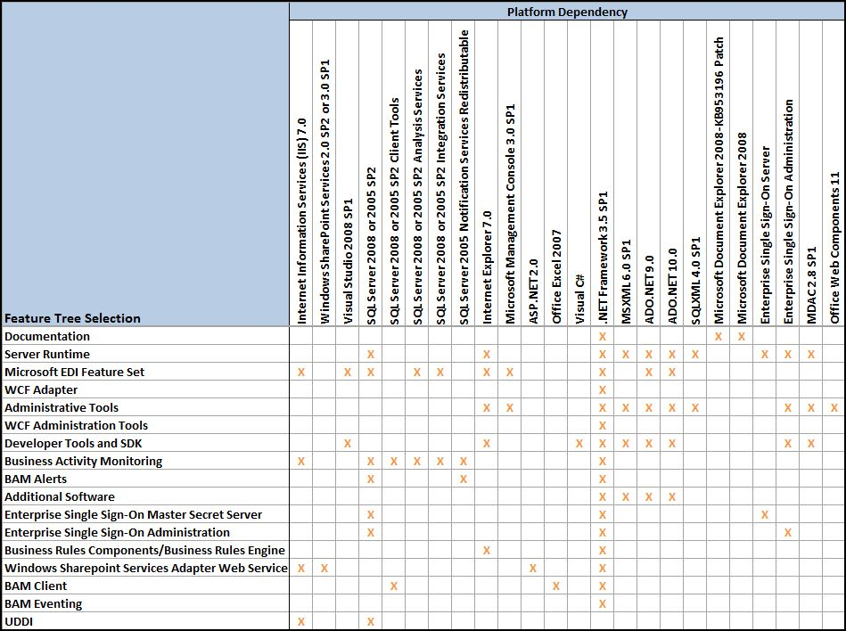

Hardware Requirements
The following table shows the minimum hardware requirements for your BizTalk Server computer. In a production environment, the volume of traffic may dictate greater hardware requirements for your servers.

Component | Minimum Requirement
Computer and processor | A computer with an Intel Pentium-compatible CPU that is:  • 1 GHz or higher for single processors  • 900 MHz or higher for double processors  • 700 MHz or higher for quad processors  Hyper-threading and dual-core processors are supported.  The 64-bit versions of BizTalk Server require a 64-bit operating system running on an x64-based system. Computers based on CPUs that are compatible with the AMD64 (x86-64) and Extended Memory 64-bit Technology (EM64T) processor architecture are considered x64-based systems.  BizTalk Server is not supported on Itanium-based systems.
Memory | 2 GB of RAM
Hard disk | 10 GB of available hard disk space for a complete installation including the operating system and all prerequisite software. The hard disk must be NTFS formatted.
Drive | CD-ROM or DVD-ROM drive
Display | Windows Server 2003-compatible VGA or higher-resolution monitor set to 1024 x 768 pixels or greater resolution
Other | Network adapter card, and Microsoft mouse or compatible pointing device

Software Requirements
This page lists the software required for running BizTalk Server. You’ll be guided through installation steps for all of these prerequisites in a later section.
Microsoft Windows Can be either Windows Server 2008, Windows Server 2003, Windows® XP with Service Pack 3 (SP3), Windows Vista® with Service Pack 1 (SP1). Itanium (IA64) editions of Windows Server 2003 are not supported by the BizTalk Server runtime, however, BizTalk databases can be hosted on SQL Server running on IA64 hardware.
Internet Information Services (IIS) Versions 6.0 and 7.0 are supported. Provides a scalable Web application infrastructure.
Required for: EDI, BAM, WSS Adapter, and UDDI.
Windows SharePoint Services A collection of services for Windows Server which you can use for sharing and collaborating. Supported versions: WSS 2.0 with Service Pack 3 (SP3), WSS 3.0 with Service Pack 1 (SP1), and Microsoft Office SharePoint Server 2007 (MOSS).
Required for: WSS Adapter.
Microsoft Office Excel 2007 Business Activity Monitoring (BAM) uses an Excel workbook to display a real-time view of business processes.
Required for: BAM.
Microsoft .NET Framework 3.5 with Service Pack 1 (SP1) The Microsoft .NET Framework 3.5 SP1 (formerly WinFX), is the new managed code programming model for Windows. It combines .NET Framework 2.0 with four new technologies: Windows Presentation Foundation (WPF), Windows Communication Foundation (WCF), Windows Workflow Foundation (WF), and Windows CardSpace (WCS, formerly “InfoCard”).
Required for: All BizTalk Server managed components.
Microsoft Visual Studio 2008 Provides a development environment for building applications that target any device and integrate with any platform. Professional Edition is recommended, but Standard and Team System are also supported.
Required for: BizTalk Server Developer Tools and SDK component.
SQL Server 2005 SP2 or 2008 A relational database server for processing high volumes of data. For optimal performance, we recommend SQL Server 2008 Enterprise Edition. In order to fully use the BizTalk Server 2009 SDK, or deploy BizTalk Server applications from a Visual Studio development environment, you must also install the SQL Server Development Tools.
Required for: BizTalk Server Runtime, EDI, and BAM.
SQL Server 2005 Notification Services Enables the use of BAM Alerts. Note that this SQL Server 2005 feature is not included in SQL Server 2008, and must be downloaded separately.
Required for: BAM Alerts.
SQLXML 4.0 with Service Pack 1 Enables XML support for your SQL Server database and allows developers to bridge the gap between XML and relational data. You can create an XML view of your existing relational data and work with it as if it were an XML file.
Required for: BizTalk Server Runtime, Administrative Tools, and BAM.

Considerations When Installing BizTalk Server 2009
You should understand the following before beginning your installation:
Account names You should use the default account names whenever possible. The BizTalk Server setup program automatically configures installed components to use the default accounts. While using the default names simplifies setup and configuration, it is not always possible. For example, there may be multiple BizTalk Server groups within an Active Domain forest. In this situation the account names must be modified to avoid conflicts. If you must change the names, note that BizTalk Server supports only <NetBIOS domain name>\<user> name formats for service accounts and Windows groups.
Account names with BAM Management Web Service BizTalk Server does not support use of either built-in accounts or accounts without passwords for the BAM Management Web Service User. This is because the web service accesses the BizTalk database, and such accounts may represent a security threat.
Configuring BizTalk Server with such accounts may appear to succeed, but the BAM Management Web Service will fail.
Note that use of such accounts for the BAM Application pool is supported.
BizTalk Assembly Viewer Use of the BizTalk Assembly viewer is not supported on a 64-bit platform.
Install and Uninstall Uninstalling BizTalk Server is fully supported. However it requires manually deleting a number of databases which can be complicated and time consuming. If you are installing BizTalk Server as a developer or evaluator, consider installing on a virtual computer. This way, if you need to reinstall, you can easily roll back to a preset checkpoint without having to go through the uninstall process.
32-bit and 64-bit computers There are relatively few differences between installing BizTalk Server on 32-bit editions of Windows compared to installation on 64-bit editions of Windows. This document covers both 32-bit and 64-bit installations. Differences between them are noted in the instructions to follow.
Workgroups Installing and configuring BizTalk Server in the workgroup environment on a single computer is supported. SQL Server and BizTalk Server features and components are installed and configured on the same computer.
Terminal Server Installing BizTalk Server using Terminal Server running in application mode is not supported. For more information, see the support article at http://go.microsoft.com/fwlink/?LinkId=88092.

Preparing Your Computer for Installation
In this section you’ll prepare your environment by installing and configuring all software prerequisites, and then creating accounts and setting permissions.
Important
You must perform these procedures in the order listed.

Install Critical Windows Updates
Before installing BizTalk Server or its prerequisites, make sure you have installed the latest critical Windows updates from Microsoft.
To install Windows updates
1. Click Start, point to All Programs, and then click Windows Update.
2. Follow the directions on the Windows Update site.
3. If prompted, restart your computer.

Enable Internet Information Services
Microsoft Internet Information Services (IIS) provides a Web application infrastructure for many BizTalk Server features. BizTalk Server requires IIS for the following features:
• HTTP adapter
• SOAP adapter
• Windows SharePoint Services adapter
• Secure Sockets Layer (SSL) encryption
• BAM Portal
To enable Internet Information Services 7.0
1. In the Windows Initial Configuration Tasks screen, under Customize the Server, click Add Roles.
2. On the Before You Begin screen, click Next.
3. On the Select Server Roles screen, click Web Server (IIS).
4. If prompted, click Add Required Features, and then click Next.
5. Review the information on the Web Server (IIS) screen, and then click Next.
6. On the Select Roles Services screen, in addition to the default values, select Application Development, and then click Add Required Features.
7. Under Security, select Basic Authentication and Windows Authentication.
8. Under Management Tools, select IIS 6 Management Compatibility, and then click Next.
9. Review the information on the Confirm Installation Selections screen, and then click Install.
10. On the Installation Results screen, click Close.

Install Microsoft Office Excel (HY: Not Needed for test/production server installs)
Microsoft Office Excel is required for using the Business Activity Monitoring (BAM) feature in BizTalk Server. You use the BAM Office Excel Workbook to define the business processes you want to monitor. You also use the BAM Excel Workbook to define the way in which business users see the data collected by BAM.
The following procedure installs only Office Excel. You can install additional Microsoft Office system applications and tools if you wish, but they are not necessary to complete the installation of BizTalk Server.
To install Microsoft Office Excel
1. Insert the Microsoft Office installation disk into the DVD-ROM drive.
2. When you reach the Type of Installation screen, select Custom Install, and then click Next.
3. On the Custom Setup screen, ensure that Excel is selected, and then click Next.
4. Click Install.
5. On the Setup Completed screen, click Finish.

Install Visual Studio 2008 with SP 1 (HY: Not needed for test/production server installs)
The BizTalk Server development tools are based on Visual Studio 2008 SP1. Therefore, at a minimum, you must have the Microsoft Visual C#® .NET portion of Visual Studio 2008 SP1 installed on your computer before installing the BizTalk Server Developer Tools and SDK component.
Visual Studio 2008 SP1 is not required if you are installing BizTalk Server on a production computer (runtime only), on which no application development or debugging will occur.
The BizTalk Server runtime components require .NET Framework 3.5 SP1. In addition, the .NET Framework 3.0 is required if the Windows Communication Foundation (WCF) adapter or WCF Interceptor is installed.
Note
If you install Visual Studio and BizTalk Server, and then upgrade to Visual Studio Team Explorer, it may be necessary to repair your BizTalk Server installation by using Control Panel - Programs and Features.
To install Visual Studio 2008
1. Insert the Visual Studio 2008 installation disk into the DVD-ROM drive.
2. Click Install Visual Studio 2008.
3. After the installation loads, click Next.
4. On the Start page, accept the license agreement, type your Product Key and any other necessary information, and then click Next.
5. On the Options page, select Custom, and then click Next.
6. Under Select features to install, clear all features except Visual C#, and then click Install.
Important
Your version of Visual Studio may include Microsoft SQL Server Express as an optional feature. Do not install this feature, as it will cause BizTalk Server setup to fail.
7. On the Finish page, click Finish.
8. On the Visual Studio Setup screen, click Exit.
To install Visual Studio 2008 SP1
1. Insert the Visual Studio 2008 SP1 installation disk into the DVD-ROM drive.
2. On the Welcome screen, click Next.
3. Accept the license terms, and then click Next to begin installation.
4. When setup is complete, click Finish.

Install SQL Server 2008 (Not needed for test/production server installs)
BizTalk Server provides the capability to specify a business process and also a mechanism by which the applications used in that business process can communicate with each other. SQL Server is the main repository for this communication mechanism. You must install either SQL Server 2008 (Enterprise Edition recommended) or SQL Server 2005 with SP2.
Important
In order to use BAM real time aggregations with SQL Server 2008, you must install SQL Server 2008 Enterprise Edition.
To install SQL Server 2008
1. Insert the SQL Server 2008 installation disk into the DVD-ROM drive. The setup program will begin automatically. If prompted for automatic installation of prerequisite software, click OK.
2. On the SQL Server Installation Center, click Installation.
3. Click New SQL Server stand-alone installation or add features to an existing installation.
4. Review the information on the Setup Support Rules screen, and then click OK.
5. On the Product Key screen, enter your product key and click Next.
6. On the License Terms screen, select I accept the license terms, and then click Next.
7. On the Setup Support Files screen, click Install.
8. On the Feature Selection screen, select the following features, and then click Next.
• Database Engine Services
• SQL Server Replication
• Full-Text Search
• Analysis Services
• Reporting Services
• Business Intelligence Development Studio
• Client Tools Connectivity
• Integration Services
• Management Tools - Basic
• Management Tools - Complete
9. On the Instance Name screen, select Default instance, and then click Next.
10. Review the information on the Disk Space Requirements screen, and then click Next.
11. On the Service Accounts screen, click Use the same account for all SQL Server instances, enter a local account or domain account and password, and then click Next.
12. On the Database Engine Configuration screen, select Windows authentication mode, click Add Current User, and then click Next.
13. On the Analysis Services Configuration screen, click Add Current User, and then click Next.
14. On the Reporting Services Configuration screen, select Install the native mode default configuration, and then click Next.
15. On the Error and Usage Reporting screen, leave the default values, and then click Next.
16. On the Installation Rules screen, review the information and resolve any issues, and then click Next.
17. On the Ready to Install screen, review the information, and then click Install.
18. On the Installation Progress screen, after setup has finished, click Next.
19. On the Complete screen, click Close.

Install Prerequisites for MQSeries Agent (Not needed for test / production server installs)
If you plan to use the MQSeries Agent, you will need to download the following:
• .NET Framework 2.0: http://go.microsoft.com/fwlink/?LinkID=61922
You will also need to download one of the following:
• IBM WebSphere MQ 5.3 with CSD 10 (or later), or
• IBM WebSphere MQ 7.0
Caution
IBM WebSphere is not supported by Microsoft, and Microsoft makes no guarantees about the suitability of this program. Use of these programs is entirely at your own risk. For more information about these utilities, including download instructions, see the IBM Web site at www.ibm.com.
Finally, you must run the MQSAgent COM+ Configuration Wizard (MQSConfigWiz.exe) on the computer where MQSAgent is installed prior to using either the MQSeries Adapter or the Windows SharePoint Services Web service.

Install SQL Notification Services (Not needed for test / production server installs)
If you plan to use BAM Alerts in your BizTalk Server project, you must install SQL Notification Services and its prerequisites on your BizTalk Server computer. This SQL Server 2005 feature is not included in SQL Server 2008, but you can install it from the Microsoft Download Center. You can skip this step if you are installing SQL Server 2005 with SP2.
To install SQL Notification Services
1. Click or navigate to the Feature Pack for Microsoft SQL Server 2005 - December 2008.
2. Depending on your platform, download the appropriate package from the following three components:
Microsoft SQL Server Native Client
• X86 Package (sqlncli.msi)
• X64 Package (sqlncli_x64.msi)
• IA64 Package (sqlncli_ia64.msi)
Microsoft SQL Server 2005 Management Objects Collection
• X86 Package (SQLServer2005_XMO.msi)
• X64 Package (SQLServer2005_XMO_x64.msi)
• IA64 Package (SQLServer2005_XMO_ia64.msi)
Microsoft SQL Server 2005 Notification Services Client Components
• X86 Package (SQLServer2005_NS.msi)
• X64 Package (SQLServer2005_NS_x64.msi)
• IA64 Package (SQLServer2005_NS_ia64.msi)

Install SQL Server 2005 with SP2 (Not needed for test / production server installs)
Although SQL Server 2008 Enterprise Edition is recommended, BizTalk Server will run on SQL Server 2005 with SP2.
To install SQL Server 2005
1. Insert the SQL Server 2005 installation disk into the DVD-ROM drive.
2. On the End User License Agreement page, accept the terms and click Next.
3. If prompted to install prerequisites, click OK. When prerequisite setup is complete, click Next.
4. On the Welcome to the Microsoft SQL Server Installation Wizard screen, click Next.
5. On the System Configuration Check screen, ensure that there are no errors before you continue, and then click Next.
6. On the Registration Information page, enter your Name, Organization (optional), and Product Key, and then click Next.
7. On the Components to Install screen, select:
• SQL Server Database Services
• Workstation components, Books Online, and development tools
If you plan to use AS2, EDI, or BAM features, then you must also select:
• Analysis Services
• Integration Services
If you plan to use BAM Alerts, then you must also select:
• Notification Services
Note
If certain features are unavailable, you may be missing some SQL Server prerequisites. Click Help on the Components to Install screen for more information.
8. After selecting all the necessary components, click Next.
Note
Depending on the features you selected in Step 7, some of the following steps may not appear.
9. On the Instance Name screen, select Default instance, and then click Next.
10. On the Service Account screen, do the following:
a. Clear the Customize for each service account check box.
b. Assign a logon account to the SQL Server services.
c. Select Use a domain account, and then enter a local or domain account and password.
Note
If the computer on which you are installing SQL Server is a member of a domain, you should use a domain local or domain global account. Local accounts are not recommended because they are neither visible nor manageable except on the computer where they were created.
d. Under Start services at the end of setup, select SQL Server Agent, and then click Next.
11. On the Authentication Mode screen, select Windows Authentication Mode, and then click Next.
12. On the Collation Settings screen, leave the default unless you have a specific requirement for a different collation, and then click Next.
Note
BizTalk Server does not support binary (case sensitive) collations.
13. On the Error and Usage Report Settings screen, either leave the defaults or elect to participate in the error reporting and feature usage programs, and then click Next.
14. On the Ready to Install screen, review the information, and then click Install.
15. On the Setup Progress screen, after setup has finished, click Next.
16. On the Completing Microsoft SQL Server 2005 Setup screen, and then click Finish.
To install SQL Server 2005 SP2
1. Browse to http://go.microsoft.com/fwlink/?linkid=86436 to download the appropriate service pack for your computer. For Windows x64 editions, download and save SQLServer2005SP2-KB921896-x64-ENU.exe to your local hard drive. For 32-bit Windows editions, download and save SQLServer2005SP2-KB921896-x86-ENU.exe to your local hard drive.
2. Locate the file you just downloaded and double-click it to run Setup. The Microsoft SQL Server 2005 Service Pack 2 Setup screen will appear. Click Next.
3. Review the license terms, select I accept the agreement, then click Next.
4. On the Feature Selection screen, click Next.
5. On the Authentication screen, verify that the authentication method is set to Windows Authentication, and then click Next.
6. On the Error and Usage Reporting Settings screen, you can leave the defaults or choose to send error and feature usage data, and then click Next.
7. The Running Processes screen will appear. Running processes with locked files that need to be updated will be displayed here. Listed processes, if any, should be shut down using the Services management tool. When there are no running processes remaining in the list, click Next.
8. The Ready to Install screen will appear. Click Install.

Install Windows SharePoint Services (Not needed for test / production server installs)
Windows SharePoint Services is a collection of services for Windows Server which enable you to share information, collaborate with other users on documents, and create lists and Web part pages. For information and procedures on installing Windows SharePoint Services, see Appendix A.
Note
You do not need to install WSS if you do not also plan to install the WSS adapter. However, if you are installing WSS, you must do it before continuing with the rest of the BizTalk Server prerequisites.
BizTalk Server 2009 supports these two versions of WSS:
• Windows SharePoint Services 3.0 with SP1
• Windows SharePoint Services 2.0 with SP3
Installing and configuring Windows SharePoint Services consists of the following procedures:
• Configure ASP.NET 2.0 for 64-bit mode
• Install Windows SharePoint Services
• Configure ASP.NET 2.0 for 32-bit mode
• Configure Default Web Site for ASP.NET 2.0
• Configure Windows SharePoint Services
• Extend the Default Web Site as a virtual server

Disable the Shared Memory Protocol (Not needed for test / production server installs)
Under certain stress conditions (such as clients accessing SQL Server from the same computer), the SQL Server Shared Memory protocol may lower BizTalk Server performance. You can resolve this problem by disabling the use of the Shared Memory network protocol in the SQL Server Client Network Utility.
To disable Shared Memory protocol for SQL Server
1. Click Start, point to All Programs, click your version of SQL Server, click Configuration Tools, and then click SQL Server Configuration Manager.
2. In SQL Server Configuration Manager, expand SQL Server Network Configuration, and then click Protocols for MSSQLSERVER.
3. Right-click Shared Memory, and then click Disable.
4. Click SQL Server Services, right-click SQL Server (MSSQLSERVER), and then click Stop. After the service has stopped, right-click SQL Server (MSSQLSERVER) again, and then click Start.
5. Close SQL Server Configuration Manager.

Join the Local Administrators Group
You must be an administrator to install and configure BizTalk Server 2009. Use this procedure to join the Administrators group on the local computer.
Join the local Administrators group
1. Click Start, click Control Panel, and then double-click User Accounts.
2. Click Manage User Accounts.
3. In the User Accounts dialog box, click the Advanced tab.
4. Under Advanced user management, click Advanced.
5. In the left-hand pane, click Groups.
6. In the right-hand pane, double-click Administrators.
7. In the Administrators Properties dialog box, look for your name in the Members list.
8. If your name is in the list, proceed to Step 9.
If your name is not in the Members list, do the following:
• Click Add.
• In the Enter the object names to select box, type your name, and then click Check Names.
• Once your name is recognized, click OK.
9. Click OK to close the Administrators Properties dialog box, and then close the Local Users and Groups pane.
10. Click OK to close the User Accounts dialog box.
11. Close the Users Accounts pane.

Configure the Application Event Log
BizTalk Server setup keeps a record of events in the Application Event Log. Depending on the BizTalk Server features installed, the amount of space required in the log may exceed its limit. If the application event log runs out of space during BizTalk Server setup, the installation will fail.
To prevent this from happening, you can change the settings in the Application Event Log.
To change settings in the Application Event Log
1. Click Start, click Control Panel, and then double-click Administrative Tools.
2. Double-click Event Viewer.
3. In the Event Viewer, expand Windows Logs.
4. Right-click Application, and then click Properties. This opens the Log Properties dialog box.
• To see how much available space your log has, compare the Log Size field with the Maximum log size field.
• To provide more space in the event log, enter a higher number in the Maximum log size field.
• To enable overwriting of old events when the log becomes full, select Overwrite events as needed.
• To clear the log events, click Clear log.
5. Click OK, close the Event Viewer, and close Administrative Tools.

Installing and Configuring SSO Master Secret Server
If we want to have multiple biztalk hosts talking to the same sql server, then we need to install the SSO Master Secret server on the SQL server. To do this, mount the Biztalk installation DVD to the sql server and run setup.
Then select only the SSO admin and SSO Master Secret server features to install.
Once installed, you can launch the Biztalk Server 2009 Configuration tool, to configure this SSO, configure as below:
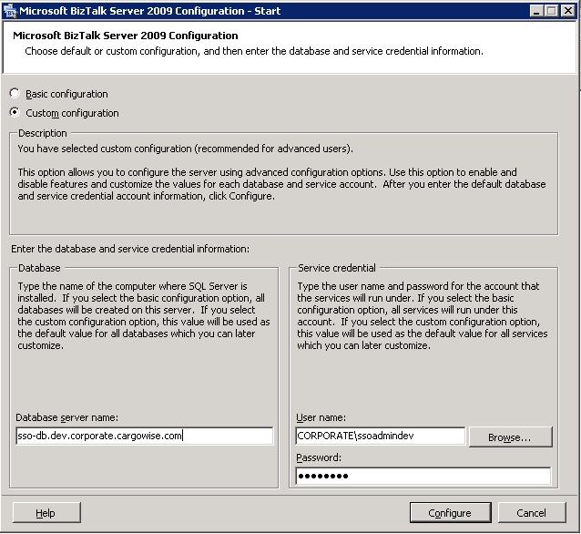

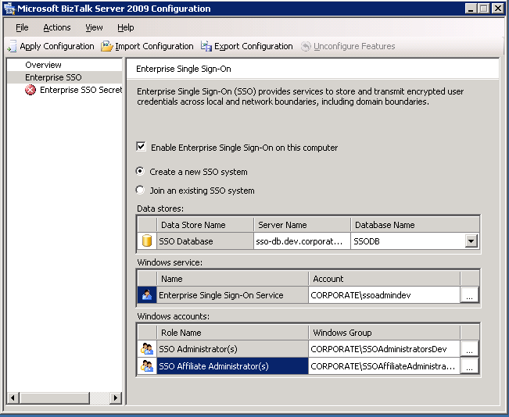

Before configuring the remaining biztalk components, you need to ensure that sql client tools are installed. Just insert the sql server disk, matching the same version as the sql server), and start the standalone install on the biztalk machine:
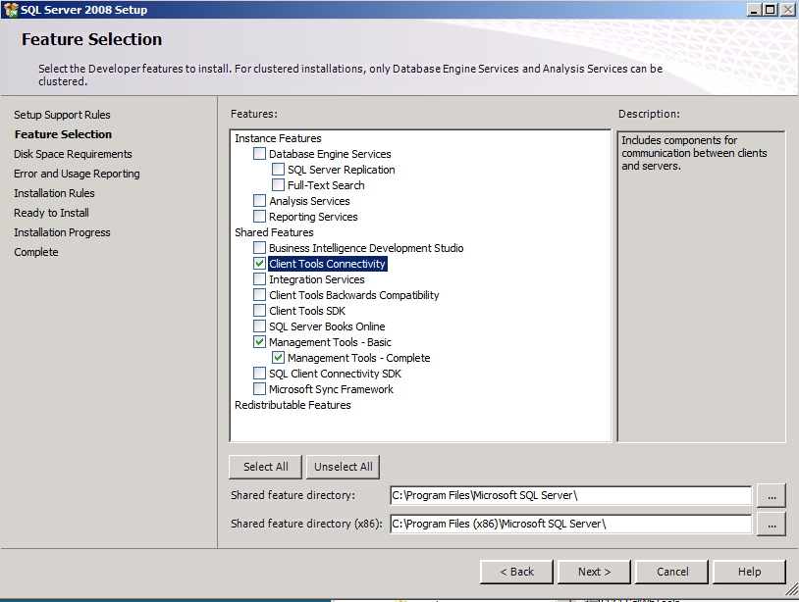

Enable DTC on the Local Host Server (on sql and on biztalk)
To facilitate transactions between SQL Server and BizTalk Server, you must enable Microsoft Distributed Transaction Coordinator (MS DTC) on the Local Host Server (LHS).
To enable Distributed Transaction Coordinator (DTC) on the LHS
1. Click Start, click Run, type dcomcnfg and then click OK to open Component Services.
2. In the console tree, expand Component Services, expand Computers, expand My Computer, expand Distributed Transaction Coordinator, and then click Local DTC.
3. Right-click Local DTC and click Properties to display the Local DTC Properties dialog box.
4. Click the Security tab.
5. Ensure that each of the following four options is selected, and all others are cleared:
• Network DTC Access
• Allow Inbound
• Allow Outbound
• No Authentication Required
6. Click OK to close the Local DTC Properties dialog box. If prompted to restart the MSDTC service, click Yes.
7. Close Component Services.
8. Open Control Panel, and then open Windows Firewall.
9. Click Change settings to display Windows Firewall Settings.
10. Click the Exceptions tab.
11. Check the box for Distributed Transaction Coordinator and click OK.
12. Close Windows Firewall.
13. On the Control Panel, double-click Administrative Tools.
14. In the right-hand pane, double-click Services.
15. In the right-hand pane of Services (Local), right-click COM+ System Application, click Restart, and wait for the service to restart.
16. Right-click and restart the Distributed Transaction Coordinator service.
17. Right-click and restart the SQL Server (MSSQLSERVER) service.
18. Close Services (Local), and then close Administrative Tools.
19. Make sure you refresh and restart the Enterprise Single Sign On service on both the sql server and the biztalk server.

Enable TCP/IP and Named Pipes
To facilitate transactions between SQL Server and BizTalk Server, you must enable TCP/IP and Named Pipes in SQL Server.
To enable TCP/IP and Named Pipes
1. Click Start, click All Programs, click SQL Server 2008, click Configuration Tools, and then click SQL Server Configuration Manager.
2. In the left-hand pane, expand SQL Server Network Configuration.
3. Click Protocols for MSSQLSERVER.
4. Verify that both TCP/IP and Named Pipes are enabled. If they are, proceed to Step 5.
If either is not, follow these steps:
• Right-click the protocol, and then click Enable.
• Repeat to enable the other protocol if necessary.
• In the left-hand pane, click SQL Services.
• In the right-hand pane, right-click SQL Server (MSSQLSERVER), and click Stop.
• When the service has stopped, right-click SQL Server (MSSQLSERVER) again, and click Start.
5. When the service has restarted, close the Configuration Manager.

Installing and Configuring BizTalk Server
In this section you’ll install BizTalk Server, confirm that the installation succeeded, and then configure BizTalk Server.
When you installed SQL Server, setup granted your account Database Administrator rights. Since these rights are also required for installing BizTalk Server, you must do one of the following:
• Use the same account you used when you installed SQL Server.
• Make sure the account you’re using now also has Database Administrator rights.
To install BizTalk Server 2009
1. Close any programs you have open.
2. Insert the BizTalk Server 2009 installation disk into the DVD-ROM drive.
3. On the Start screen, click Install Microsoft BizTalk Server 2009 on this computer.
4. On the Customer Information screen, type your user name and organization, enter your product key, and then click Next.
5. On the License Agreement screen, click Yes, I accept the terms of the license agreement, and then click Next.
6. On the Component Installation screen, review the available components and select the ones you want to install. In eHub’s case, you still need to install the SSO administration component, but not the master/secret server, if it was already installed on the sql server.
Ensure Windows Communication Foundation components are ticked for the install, otherwise you will not be able to use the WCF adaptors.
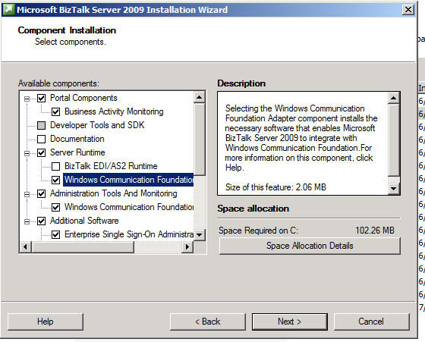

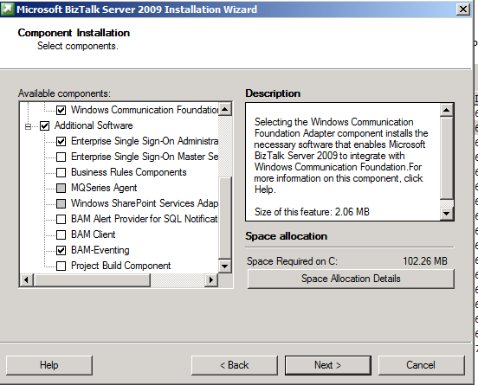

7. Accept the default installation location or click Browse to move to the location where you want to install BizTalk Server 2009, and then click Next.
8. If your computer is missing a prerequisite component such as ADOMD.NET, Setup can install the redistributable prerequisites. You can either:
• Select Automatically install the redistributable prerequisites from the web OR
• Select Automatically install the redistributable prerequisites from a CAB file if you have downloaded the CAB file. If you select this, you can then browse to the location of the CAB file and select it.
9. On the Summary screen, verify that the components that you select to install are correct.
10. To enable auto-logon after a system reboot, click Set and provide your logon information. Auto-logon is enabled only for reboots during setup, and is disabled when setup is complete.
11. Click Install to start the installation process.
12. On the Installation Completed screen, clear the Launch BizTalk Server Configuration check box, and then click Finish.

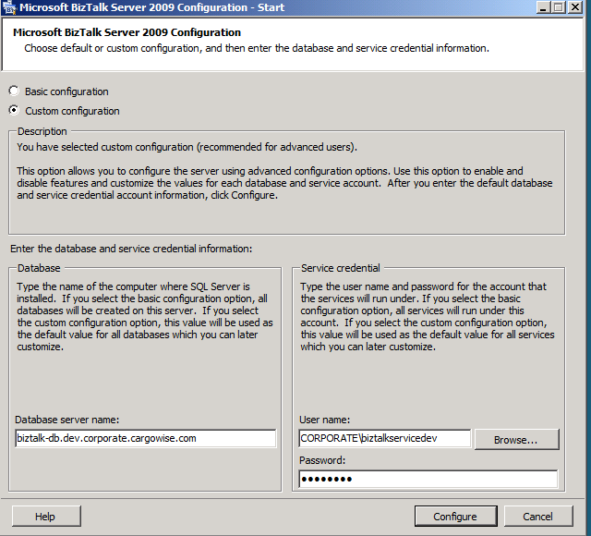

With each of the below components, I advise you to apply them one at a time. Otherwise, if one component fails to configure, it may leave behind biztalk databases, and you’ll have to close the configuration application in order to remove those database, and you’ll have to start the install from scratch again and reentering all the server names etc.

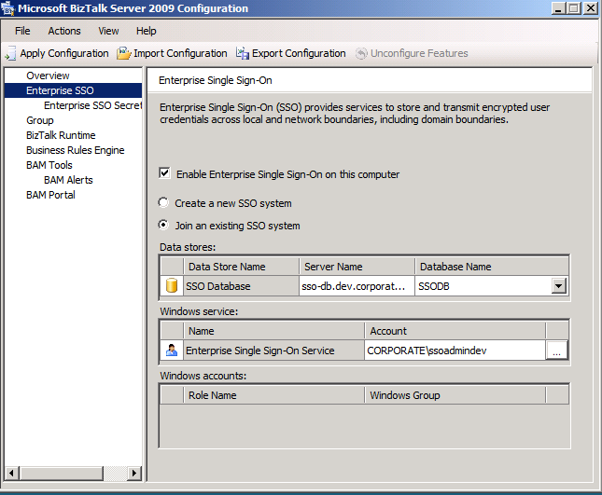

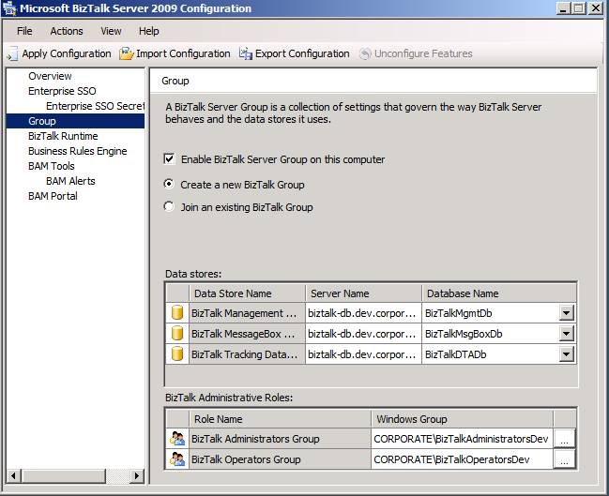

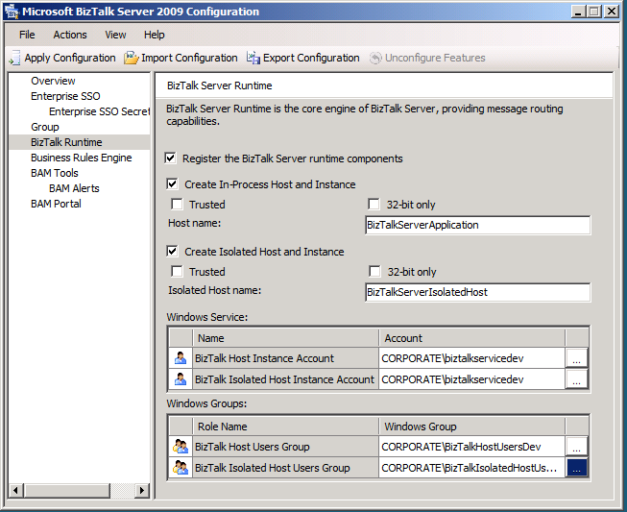

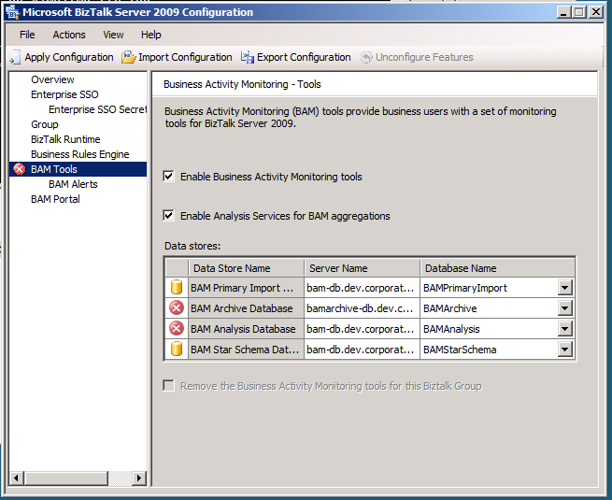

Once installed, open biztalk administration, and open properties of the biztalk group and change the SSO Server name to the DNS name:

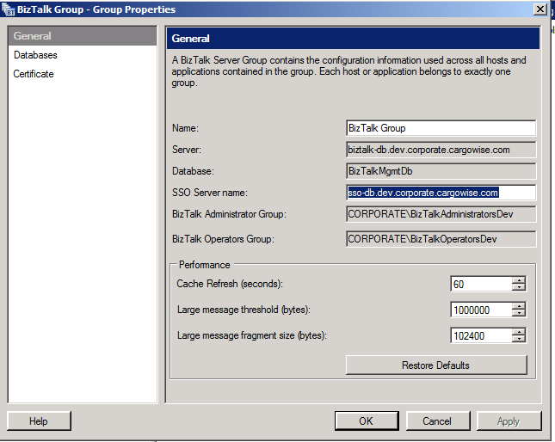

Verify Your Installation
You can check to see whether your installation was successful by using either Programs and Features or the Registry.
To verify installation using Programs and Features
1. Click Start, click Control Panel, and double-click Programs and Features.
2. When the list is fully populated, look for BizTalk Server 2009. If it appears in the list, setup succeeded.
To verify installation using the Registry
1. Open a command prompt.
2. Type regedit and then press Enter.
3. When the Registry opens, browse to HKEY_LOCAL_MACHINE\SOFTWARE\Microsoft\BizTalk Server\3.0
4. If files exist in the 3.0 folder, setup succeeded.
5. Close the Registry, and then close the command prompt.

Configure BizTalk Server
Use the following procedure to complete a basic configuration of BizTalk Server. For information on customizing your configuration, see Custom Configuration in the BizTalk Server Help.
To configure BizTalk Server 2009 using Basic Configuration
1. Click Start, click All Programs, click Microsoft BizTalk Server 2009, right-click BizTalk Server Configuration, and then click Run as Administrator.
2. In the Database field, enter the name of the local computer.
3. In the Service Credential field, type the User name and Password for the account that the BizTalk services will run under.
4. Click Configure.
Note
You may receive a warning if you enter a user name with administrative credentials on this computer. Click OK to continue.
5. On the Summary screen, review the configuration about to be performed, and then click Next.
6. On the Completion screen, click Finish.

Uninstalling BizTalk Server
Use the procedures in the following pages to uninstall BizTalk Server 2009.
Important
At this point you have successfully installed BizTalk Server. If you want to uninstall BizTalk Server, use the following procedures. Otherwise, stop here.
Important
The following procedures list numerous jobs, packages, and databases to be deleted. The names listed here are only the default names. In your deployment of BizTalk Server the names may have been changed.
Important
You must perform these actions in the order shown, or uninstallation will not be complete.

Uninstall BizTalk Runtime Components
To uninstall BizTalk Server 2009 runtime components
1. Click Start, point to Control Panel, and then click Programs and Features.
2. In the Programs and Features dialog box, click Microsoft BizTalk Server 2009, and then click Uninstall/Change.
3. On the Program Maintenance screen, select Remove, and then click Next.
4. On the Summary screen, review the components to be uninstalled, and then click Uninstall.
5. On the Uninstall Completed screen, click Finish.

Uninstall Enterprise Single Sign-On
To uninstall Enterprise SSO services
1. Click Start, point to Control Panel, and then click Programs and Features.
2. In the Programs and Features dialog box, click Microsoft Enterprise Single Sign-On, and then click Uninstall/Change.
3. On the Program Maintenance screen, select Remove, and then click Next.
4. On the Summary screen, review the components to be uninstalled, and then click Uninstall.
5. On the Uninstall Completed screen, click Finish.

Remove All Remaining Components
Remove SQL Server agent jobs
1. Click Start, point to All Programs, point to your version of SQL Server, point to SQL Server Management Studio, and then click SQL Server Management Studio.
2. Click Connect.
3. In Object Explorer, expand SQL Server Agent, and then expand Jobs.
4. Remove the following jobs:
• Backup BizTalk Server (BizTalkMgmtDb)
• CleanupBTFExpiredEntriesJob_BizTalkMgmtDb
• DTA Purge and Archive (BizTalkDTADb)
• MessageBox_DeadProcesses_Cleanup_BizTalkMsgBoxDb
• MessageBox_Message_Cleanup_BizTalkMsgBoxDb
• MessageBox_Message_ManageRefCountLog_BizTalkMsgBoxDb
• MessageBox_Parts_Cleanup_BizTalkMsgBoxDb
• MessageBox_UpdateStats_BizTalkMsgBoxDb
• Operations_OperateOnInstances_OnMaster_BizTalkMsgBoxDb
• PurgeSubscriptionsJob_BizTalkMsgBoxDb
• Rules_Database_Cleanup_BizTalkRuleEngineDb
• TrackedMessages_Copy_BizTalkMsgBoxDb
Note
If you deployed BAM, you may also need to remove the job named bam_<Cube Name>_<View Name>.
Remove SQL Server Integration Services Packages
1. Click Start, point to All Programs, point to your version of SQL Server, point to SQL Server Management Studio, and then click SQL Server Management Studio.
2. Click Connect.
3. In Object Explorer, click Connect and select Integration Services, and then click Integration Services.
4. Expand Stored Packages and expand MSDB.
5. Remove the packages with the following prefixes:
• BAM_AN_<Cube Name>
• BAM_DM_<View Name>

Remove BizTalk Server 2009 databases
1. Click Start, point to All Programs, point to your version of Microsoft SQL Server, and then click SQL Server Management Studio.
2. In Object Explorer, expand Databases.
3. Remove the following databases:
• BAMAlertsApplication
• BAMAlertsNSMain
• BAMArchive
• BAMPrimaryImport
• BAMStarSchema
• BizTalkDTADb
• BizTalkMgmtDb
• BizTalkMsgBoxDb
• BizTalkRuleEngineDb
• SSODB
Remove BizTalk Server 2009 Analysis Service databases on SQL Server 2008
1. Click Start, point to All Programs, point to Microsoft SQL Server, point to Analysis Services, and then click Analysis Manager.
2. In Analysis Manager, expand Analysis Servers, and then expand your local server.
3. Remove the following databases:
• BizTalkAnalysisDB
• BAMAnalysis
Remove BAM Alerts Notification Services instance
1. Click Start, point to All Programs, point to Microsoft SQL Server 2005, and then click Configuration Tools..
2. On the Configuration Tools menu, click Notification Services Command Prompt
3. Type the following command to disable the instance: nscontrol disable -name BAMAlerts.
4. Type the following command to stop the instance: net stop NS$BAMAlerts.
5. Type the following command to unregister the instance: nscontrol unregister -name BAMAlerts.
Note
The BAM Notification name is generated as NS$<Prefix for Alerts Database Name> where <Prefix for Alerts Database Name> is what you specified on the BAM Alerts configuration page. The default name is BAMAlerts.

Uninstallation Complete
At this point you have fully uninstalled BizTalk Server 2009.

Appendix A: Installing Windows SharePoint Services
Use the information and procedures in this section to install and configure Windows SharePoint Services.

Considerations for Installing Windows SharePoint Services
BizTalk Server requires Windows SharePoint Services (WSS) to support the Windows SharePoint Services adapter Web service. If you do not intend to install this feature, you do not need to install WSS.
BizTalk Server 2009 supports Windows SharePoint Services 2.0 with SP3 and Windows SharePoint Services 3.0 with SP1, or Microsoft Office SharePoint Server 2007 (MOSS). Not all BizTalk Server features are compatible with all versions of Windows SharePoint Services.
Windows SharePoint Services support in BizTalk Server 2009 is summarized in the following table:

Windows SharePoint Services version | WSS adapter | BAM portal
Windows SharePoint Services 2.0 with SP2. Support for 64-bit systems is provided by WOW64. IIS and ASP.NET must run in 32-bit mode. | 32-bit only | 32-bit only
Windows SharePoint Services 3.0, or Microsoft Office SharePoint Server 2007. WSS 3.0 and MOSS require IIS and ASP.NET to run in 64-bit mode on 64-bit Windows editions. | 32-bit on Windows 32-bit x86 editions. The WSS adapter is supported in 32-bit (WOW64) or native 64-bit modes on 64-bit Windows editions | Not supported

Before you install Windows SharePoint Services, consider the following:
• BizTalk Server 2009 supports side-by-side installation of Windows SharePoint Services 2.0 with SP2 and Windows SharePoint Services 3.0.
• Although the Windows SharePoint Services adapter supports WSS 2.0 with SP3, WSS 3.0 with SP1, and MOSS 2007, the adapter can only be configured to use one version at a time.
• If you plan a side-by-side installation of WSS 2.0 and WSS 3.0, you should install WSS 3.0 before WSS 2.0. If WSS 3.0 is installed after WSS 2.0, the WSS 3.0 Setup Wizard will automatically attempt to upgrade the existing WSS 2.0 installation. Installing WSS 3.0 first will avoid this problem.
• On 64-bit Windows, both IIS and ASP.NET must be configured to run in 64-bit mode before installing WSS 3.0.
• On 64-bit Windows, both IIS and ASP.NET must be configured to run in 32-bit mode before installing WSS 2.0.
• Although side-by-side installation of WSS 2.0 and WSS 3.0 is supported on 64-bit Windows, side-by-side execution is not supported. WSS 2.0 requires IIS and ASP.NET to run in 32-bit mode on 64-bit Windows, however, WSS 3.0 requires IIS and ASP.NET to run in 64-bit mode. IIS can only run in one mode, 32-bit or 64-bit, at any given time on 64-bit Windows. This prevents side-by-side execution of WSS 2.0 and WSS 3.0.
• Side-by-side installation and side-by-side execution of WSS 2.0 and WSS 3.0 is supported on Windows 32-bit x86 editions. This means that it is possible to configure the WSS adapter Web service to use WSS 3.0, and simultaneously host the BAM portal using WSS 2.0. This configuration is only possible on Windows 32-bit x86 editions.
• Windows SharePoint Services 3.0 requires Microsoft .NET Framework 3.0. The .NET Framework must be installed prior to installing Windows SharePoint Services 3.0.
• The Windows SharePoint Services installation type must be Server Farm. This is true even if you are performing a single-server installation of BizTalk Server 2009. The Server Farm type of installation allows you to configure WSS to use the databases you specify.
For more information about the versions of Windows SharePoint Services that are supported for use with BizTalk Server 2009 see the BizTalk Server online Help topic Windows SharePoint Services Support in BizTalk Server 2009.

Configure ASP.NET 2.0 for 64-bit Mode
The following procedure only applies to the 64-bit Windows editions. You must configure IIS and ASP.NET 2.0 to run in 64-bit mode before installing WSS 3.0 SP1. You do not have to perform this step if you do not plan to install WSS 3.0 SP1.
Configure ASP.NET 2.0 for 64-bit mode
1. Click Start, click Run, type cmd, and then click OK.
2. Type the following command to enable the 64-bit mode:
cscript %Systemdrive%\inetpub\adminscripts\adsutil.vbs SET W3SVC/AppPools/Enable32bitAppOnWin64 0
3. Type the following command to install the version of ASP.NET 2.0 (64-bit) and to install the script maps at the IIS root and under:
%Systemroot%\Microsoft.NET\Framework64\v2.0.50727\aspnet_regiis.exe -i -enable
4. Type the following command to reset IIS:
IISRESET
5. Close the command prompt.
6. Open Control Panel, open Administrative Tools, and then open Internet Information Services (IIS) Manager.
7. Expand Local Computer.
8. Click Web Service Extensions.
9. In the right-hand pane, click ASP.NET v2.0.50727.
10. Click Allow.
11. Close IIS Manager.

Install Windows SharePoint Services
Use the following procedure to install Windows SharePoint Services.
To install Windows SharePoint Services 3.0 with SP1
1. BizTalk Server 2009 requires Microsoft .NET Framework 3.5, which must be installed before beginning installation of Windows SharePoint Services 3.0 with SP1. The .NET Framework is available for download at http://go.microsoft.com/fwlink/?linkid=109422.
2. Browse to http://go.microsoft.com/fwlink/?linkid=122886 (32-bit x86) or http://go.microsoft.com/fwlink/?linkid=122887 (64-bit x64). Download the installation package to your hard disk.
3. Locate the package you just downloaded (SharePoint.exe), then double-click the package to start setup.
4. On the End User License Agreement screen, select I accept the terms in the License Agreement, and then click Continue.
5. Under Choose the installation you want, click the Advanced button.
6. On the Server Type tab, select Web Front End, and then click Install Now.
7. When installation is completed, clear the box for Run the SharePoint products and technologies Configuration Wizard, then click Close. You will not configure anything at this time.

Configure ASP.NET 2.0 for 32-bit mode
If your system is using IIS 6.0 on 64-bit Windows, you must configure both IIS and ASP.NET 2.0 to run in 32-bit mode before installing Windows SharePoint Services. If you are running IIS 7.0, this step is not necessary.
Configure ASP.NET 2.0 for 32-bit mode
1. Click Start, click Run, type cmd, and then click OK.
2. Type the following command to enable the 32-bit mode:
cscript %Systemdrive%\inetpub\adminscripts\adsutil.vbs SET W3SVC/AppPools/Enable32bitAppOnWin64 1
3. Type the following command to install the version of ASP.NET 2.0 (32-bit) and to install the script maps at the IIS root and under:
%Systemroot%\Microsoft.NET\Framework\v2.0.50727\aspnet_regiis.exe -i -enable
4. Type the following command to reset IIS:
IISRESET
5. Close the command prompt.
6. Open Control Panel, open Administrative Tools, and then open Internet Information Services (IIS) Manager.
7. Expand Local Computer.
8. Click Web Service Extensions.
9. In the right-hand pane, click ASP.NET v2.0.50727.
10. Click Allow.
11. Close IIS Manager.

Configure Default Web Site for ASP.NET 2.0
In this procedure you configure the Default Web Site for ASP.NET 2.0. This must be done prior to installing the Windows SharePoint Services adapter for BizTalk Server.
Note
The following procedure applies to 32-bit Windows only. There are no user-configurable options for ASP.NET 2.0 on 64-bit systems. For more information, see http://go.microsoft.com/fwlink/?linkid=99413.
To configure Default Web Site for ASP.NET 2.0
1. Click Start, point to Administrative Tools, and then click Internet Information Services (IIS) Manager.
2. In Internet Information Services (IIS) Manager, expand your server, expand Web Sites, right-click Default Web Site, and then click Properties.
3. In Default Web Site Properties, click the ASP.NET tab.
4. The ASP.NET Version drop-down list, select 2.0.50727.0, and then click OK.
5. Close IIS Manager.

Configure Windows SharePoint Services
Use the following procedure to finish configuring Windows SharePoint Services.
Note
This procedure (and the configuration procedures that follow) suggests generic names for objects such as the application pool and Windows SharePoint Services database. You are free to substitute names to suit your organizational requirements and preferences, however, be sure to use the correct names in place of the generic names in the configuration procedures following this one.
To configure Windows SharePoint Services
1. Click Start, point to Administrative Tools, and then click SharePoint 3.0 Central Administration.
Note
Because you did not finish the configuration earlier, you are presented with the configuration screens for Windows SharePoint Services.
2. The SharePoint Products and Technologies Configuration Wizard opens. On the Welcome to SharePoint Products and Technologies screen, click Next. If prompted to start services, click Yes.
3. On the Connect to a server farm screen, select No, I want to create a new server farm, and then click Next.
4. On the Specify Configuration and Database Settings screen, enter the database server, and leave the default database name. Enter a valid username and password, and then click Next.
5. On the Configure SharePoint Central Administration Web Application screen, leave the default values, and then click Next.
6. Review the information on the Completing the SharePoint Products and Technologies Configuration Wizard screen, and then click Next.
7. On the Configuration Successful screen, click Finish.

Extend the Default Web Site as a Virtual Server
Microsoft Windows SharePoint Services uses virtual servers to host Web sites on your server. The process of applying Windows SharePoint Services to a virtual server is called extending. You must extend a virtual server with Windows SharePoint Services before you can create a Web site based on Windows SharePoint Services. In the following procedure you extend the Default Web Site as a Windows SharePoint Services virtual server.
Before proceeding you need to create a service account that Windows SharePoint Services will use when accessing the SharePoint database.
To extend the Default Web Site as a virtual server
1. Click Start, point to Administrative Tools, and then click Microsoft SharePoint Services 3.0 Central Administration.
2. Navigate to the Application Management page.
3. Under SharePoint Web Application Management, click Create or Extend Web Application.
4. On the Create or Extend Web Application page, click Extend an existing Web application.
5. On the Extend Web Application to Another IIS Web Site page, under Web Application, select Change Web Application.
6. On the Select Web Application page, select SharePoint Central Administration v3.
7. In the IIS Web Site section, click Use an existing IIS Web site.
8. From the drop-down list, select Default Web Site.
9. Leave the rest of the default values, and then click OK.

Appendix B: Silent Installation
BizTalk Server 2009 enables automated electronic software distribution, also known as silent installation. You use silent installation to install BizTalk Server 2009 in an automated way on computers that have the same configurations. Silent installation lets system administrators who want to install BizTalk Server 2009 on remote computers do so without user intervention. With a silent installation, a user does not have to monitor the installation and provide input.
To perform a silent installation, use the command-line options provided to suppress all interaction and to provide parameters for all options.
When you perform a silent installation, the installation program does not display messages. Instead, a log file captures the installation information that includes whether the installation was successful. You can then review the log file and determine the results of the installation.
To perform a BizTalk Server 2009 silent installation
1. Click Start, point to All Programs, point to Accessories, and then click Command Prompt.
2. To start the silent installation, at the command prompt, type setup.exe /<command name> <options>, and then press ENTER.
3. Check the installation status in the log file.

Command name | Option | Description
/HELP, or /?, or /H |  | Provides help and quick reference.
/QUIET |  | Suppresses UI during setup – all dialog boxes, errors, or prompts requiring user input. All messages are entered into the setup log file.  Note  The Quiet flag cannot be specified for an upgrade, because upgrade requires user confirmation of selected options.
/CABPATH | <CAB file location> | Indicates the location of the redistributable CAB file.
/S | <Configuration XML file> | Performs a silent installation of features found in the specified configuration file.  Note  To install all features, specify ALL for the InstalledFeature parameter of the configuration XML file.
/PASSIVE |  | Performs a passive installation. The setup program only displays the progress bar.
/NORESTART |  | Suppresses restart prompts and automatic restarts at the end of the installation.
/FORCERESTART |  | Always forces a restart after the installation is complete.
/PROMPTRESTART |  | Prompts the user before restarting.
/X or /UNINSTALL |  | Uninstalls BizTalk Server 2009.
/L | <Logfile> [i][w][e][a][r][u][c][m][p][v][*] | Writes logging information to a log file to the specified path. Always uses verbose Windows Installer logging and it appends to an existing file.  The following flags indicate which information to log:  i - Status messages  w - Nonfatal warnings  e - All error messages  a - Startup of actions  r - Action-specific records  u - User requests  c - Initial user interface parameters  m - Out-of-memory  p - Terminal properties  v – Verbose output  * - All
/IGNOREDEPENDENCIES |  | Bypasses the checks for downloadable prerequisites.
/INSTALLDIR <install path> | <program files folder> | Specifies the full path to product install location.
/COMPANYNAME | <company name> | Sets the company or organization name.
/USERNAME | <user name> | Sets the user name.
/ADDLOCAL ALL |  | Installs all features.
/REMOVE ALL |  | Removes all features.
/REPAIR ALL |  | Repairs all features.

Appendix C: Redistributable CAB Files
BizTalk Server relies on diverse products and technologies to provide essential services and features. This software will be installed on your computer during the installation of BizTalk Server if it is not already present. Setup gives you the option of downloading software prerequisites from the Web or extracting them from CAB files that you download before running setup.
Important
You cannot use CAB files from previous versions of BizTalk Server to install BizTalk Server 2009, including CAB files intended for BizTalk Server 2006. To ensure that you have the correct CAB file, please download the latest version from the links given in the tables below.
Note
You cannot download the CAB files through a Telnet session.
Each CAB file contains localized versions of the following software:·
• Microsoft Office 2003 Web Components (OWC11) Version 4
• Microsoft Data Access Components (MDAC) 2.8 with SP1
• Microsoft XML Core Services (MSXML) 6.0 with SP1
• Microsoft .NET Framework 3.5 with SP1
• SQLXML 4.0 with SP1
• ADOMD.NET 9.0
• ADOMD.NET 10

CAB Files (32-Bit Editions)
The following table provides the locations of the localized CAB files for BizTalk Server 2009 running on 32-bit Windows.

Language | Link
CN | http://go.microsoft.com/fwlink/?LinkId=138895&clcid=0x804
DE | http://go.microsoft.com/fwlink/?LinkId=138887&clcid=0x407
EN | http://go.microsoft.com/fwlink/?LinkId=137254
ES | http://go.microsoft.com/fwlink/?LinkId=138889&clcid=0x40a
FR | http://go.microsoft.com/fwlink/?LinkId=138953&clcid=0x40c
IT | http://go.microsoft.com/fwlink/?LinkId=138891&clcid=0x410
JA | http://go.microsoft.com/fwlink/?LinkId=138900&clcid=0x411
KO | http://go.microsoft.com/fwlink/?LinkId=138965&clcid=0x412
TW | http://go.microsoft.com/fwlink/?LinkId=138898&clcid=0x404

CAB Files (64-Bit Editions)
The following table provides the locations of the localized CAB files for BizTalk Server 2009 running on 64-bit editions of Windows.

Language | Link
CN | http://go.microsoft.com/fwlink/?LinkId=138932&clcid=0x804
DE | http://go.microsoft.com/fwlink/?LinkId=138914&clcid=0x407
EN | http://go.microsoft.com/fwlink/?LinkId=137261
ES | http://go.microsoft.com/fwlink/?LinkId=138931&clcid=0x40a
FR | http://go.microsoft.com/fwlink/?LinkId=138956&clcid=0x40c
IT | http://go.microsoft.com/fwlink/?LinkId=138962&clcid=0x410
JA | http://go.microsoft.com/fwlink/?LinkId=138925&clcid=0x411
KO | http://go.microsoft.com/fwlink/?LinkId=138968&clcid=0x412
TW | http://go.microsoft.com/fwlink/?LinkId=138933&clcid=0x404

